**Modification of** “charAt” **to** “substring”:

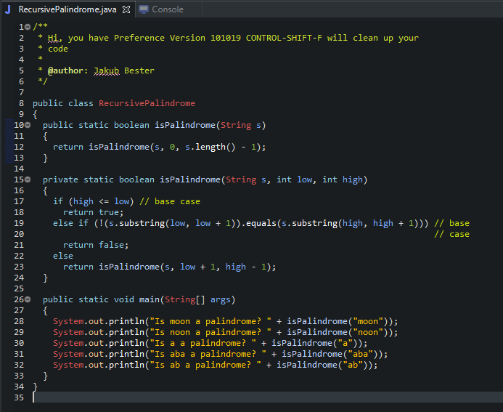

**Modification to Cause** StackOverFlow **Exception:**



